A FIELD PROJECT REPORT ON
ONLINE CAR RENTAL MANAGEMENT SYSTEM
Submitted
in partial fulfilment of the requirements for the award of the degree

BACHELOR OF TECHNOLOGY
In
COMPUTER SCIENCE AND ENGINEERING

By
Ch Divya | 241FA04C23
G Tarun Reddy | 241FA04D12
Y Lakshmi Sravya | 241FA04D19
P Varun Gopal | 241FA04D28
Under the Guidance of
Kolla. Jyotsna
Asst.professor,CSE


Department of Computer Science and Engineering
School of Computing and Informatics
Vignan’s Foundation for Science, Technology and Research (Deemed to be University) Vadlamudi, Guntur, Andhra Pradesh-522213, India.
April – 2026


CERTIFICATE

This is to certify that the field project entitled “Online Car Rental Management System” is being submitted by (Ch Divya & 241FA04C23), (G Tarun Reddy & 241FA04D12), (Y Lakshmi Sravya & 241FA04D19), and (P Varun Gopal & 241FA04D28) in partial fulfilment of the requirements for the degree of Bachelor of Technology (B.Tech) in Computer Science and Engineering at Vignan’s Foundation For Science Technology & Research (Deemed to be University), Vadlamudi, Guntur District, Andhra Pradesh, India.
This is a bona fide work carried out by the aforementioned students under my guidance and supervision.

Guide

Project Review Committee | Head of the Department



DECLARATION
Date:
We hereby declare that the work presented in the field project titled ” Online Car Rental Management System”, is the result of our own efforts and investigation. This project is being submitted under the supervision of (Kolla Jyotsna, Asst.professor, CSE), in partial fulfilment of the requirements for the Bachelor of Technology (B.Tech) degree in Computer Science and Engineering at Vignan’s Foundation for Science, Technology and Research (Deemed to be University), Vadlamudi, Guntur, Andhra Pradesh.

Ch Divya | 241FA04C23
G Tarun Reddy | 241FA04D12
Y Lakshmi Sravya | 241FA04D19
P Varun Gopal | 241FA04D28

 |  |  | 
 |  |  | 5
 |  |  | 5
 |  |  | F 6
 |  |  | 6
 |  |  | 7
 |  |  | 7
 |  |  | 7-8
 |  |  | 8
 |  |  | 8
 |  |  | 9
 |  |  | 9
 |  |  | 9-10
 |  |  | 10-13
 |  |  | 14
 |  |  | 14-16
 |  |  | 16
 |  |  | 17
 |  |  | 18

1.INTRODUCTION
Online Car Rental Management System is a web-based application designed to make the process of renting vehicles simple, fast, and efficient. The system allows customers to search for available cars, view vehicle details such as price, model, and availability, and book cars online without visiting the rental office. It reduces manual paperwork and saves time for both customers and administrators.
The system also provides secure user registration and login, online booking, and payment facilities. Administrators can manage vehicle information, customer records, booking details, and rental status through a centralized database. This helps in maintaining accurate records and improving overall service quality. By automating car rental operations, the online car rental management system increases efficiency, reduces errors, and offers better convenience to users.
This system benefits both customers and administrators. Customers can access the platform anytime and from anywhere, making the booking process convenient and time-efficient. They can view vehicle categories, rental charges, availability status, and payment options in real time. On the other hand, administrators can manage vehicle records, monitor bookings, track payments, and maintain customer data through a centralized dashboard.
Overall, the Online Car Rental Management System aims to provide an efficient, reliable, secure, and user-friendly digital platform that modernizes traditional car rental operations. By automating booking procedures and improving data management, the system enhances customer experience while optimizing administrative processes. It serves as a practical example of how web-based technologies can be applied to real-world business applications to improve service delivery and operational performance.
1.1 PROBLEM DEFINITION
In today’s fast-paced world, customers expect quick and convenient services. However, traditional car rental systems are largely manual and inefficient. Customers are required to physically visit rental offices, inquire about vehicle availability, fill out forms, and wait for confirmation. This process is time-consuming and inconvenient, especially for users who need immediate service.
Another major issue is the lack of real-time information. Customers cannot easily check which vehicles are available, compare prices, or plan their bookings in advance. This leads to poor user experience and dissatisfaction.
From the administrator’s perspective, maintaining records manually is difficult and error-prone. Managing customer details, vehicle availability, booking schedules, and payments without automation increases the chances of data inconsistency and duplication. Additionally, generating reports and tracking business performance becomes challenging.
Therefore, there is a strong need for a digital solution that automates the entire process. The system should provide real-time access, reduce manual work, improve accuracy, and enhance overall efficiency for both users and administrators.
1.2 EXISTING SYSTEM
The existing car rental system mainly operates through manual processes or partially computerized methods.
Working of Existing System:
Customers visit the rental office
Staff checks vehicle availability manually
Booking is recorded on paper or simple software
Payment is handled offline
Disadvantages:
Time-consuming and inefficient
No real-time updates
High dependency on staff
Risk of data loss or duplication
Limited accessibility (only office hours)
Poor customer experience
1.3 PROPOSED SYSTEM
The proposed system is a fully web-based application designed to overcome the limitations of the existing system.
Key Features:
Online registration and login
Real-time car availability display
Easy booking process
Secure data handling
User-friendly interface
Advantages:
Accessible anytime and anywhere
Faster booking process
Reduced manual errors
Better data management
Improved customer satisfaction
1.4 LITERATURE REVIEW
Various researchers have worked on online rental systems and web-based applications.
Studies show that automation improves operational efficiency and reduces manual errors
Web-based systems provide better accessibility and flexibility
Online booking systems enhance customer satisfaction and service quality
Integration of databases ensures secure and structured data storage
These studies highlight the importance of digital transformation in service-based industries like car rentals.
2. SYSTEM REQUIREMENTS
System requirements define the resources needed to develop and run the application efficiently.
They are divided into:
- Hardware requirements
- Software requirements
- Functional requirements
- Non-functional requirements
2.1 Hardware and Software Requirements
Hardware Requirements:
The system does not require high-end hardware, as it is a lightweight web-based application. The following configuration is sufficient:
Processor: Intel Core i3 or higher
RAM: Minimum 4 GB (8 GB recommended for smooth performance)
Hard Disk: At least 500 MB free space
Display: Standard monitor with 1024×768 resolution or higher
Input Devices: Keyboard and mouse
Internet Connection: Required for accessing the web application
Explanation:
The hardware requirements are minimal because the system runs on a web browser. Even a basic computer or laptop can support the application efficiently. Higher RAM and processor speed improve performance when handling multiple operations.
Software Requirements:
The system is developed using basic web technologies and requires the following software:
Operating System: Windows 10/11, Linux, or macOS
Web Browser: Google Chrome, Mozilla Firefox, Microsoft Edge
Development Tool: Visual Studio Code (or any text editor)
Programming Languages: HTML, CSS, JavaScript
Storage: Browser Local Storage
Optional Tools: Git (for version control)
Explanation:
HTML is used for creating the structure of web pages
CSS is used for designing and styling
JavaScript is used for implementing functionality and logic
Local Storage is used to store user and booking data
Modern browsers support all these technologies, making the system easy to develop and run without additional software installations.

2.2 SOFTWARE REQUIREMENTS SPECIFICATION (SRS)
Functional Requirements:
- User should be able to register and login
- System should display available cars
- User should be able to book a car
- System should store booking details
- User should be able to contact admin
- Admin should manage system data
Non-Functional Requirements:
- System should be easy to use
- Fast response time
- Secure user data
- Reliable and consistent performance
- Compatible with multiple browsers
3. SYSTEM DESIGN
The system design defines how the system is structured and how components interact.
Design Approach:
- Client-side web application
- Modular structure for easy maintenance
Components:
- Frontend (UI)
- Business logic (JavaScript)
- Data storage (Local Storage)
3.1 MODULES OF SYSTEM
Each module performs a specific function:
- Registration Module – Creates user accounts
- Login Module – Authenticates users
- Car Listing Module – Displays available vehicles
- Booking Module – Handles reservations
- Contact Module – Handles user queries
- Feedback Module – Collects user opinions
3.2 UML DIAGRAM
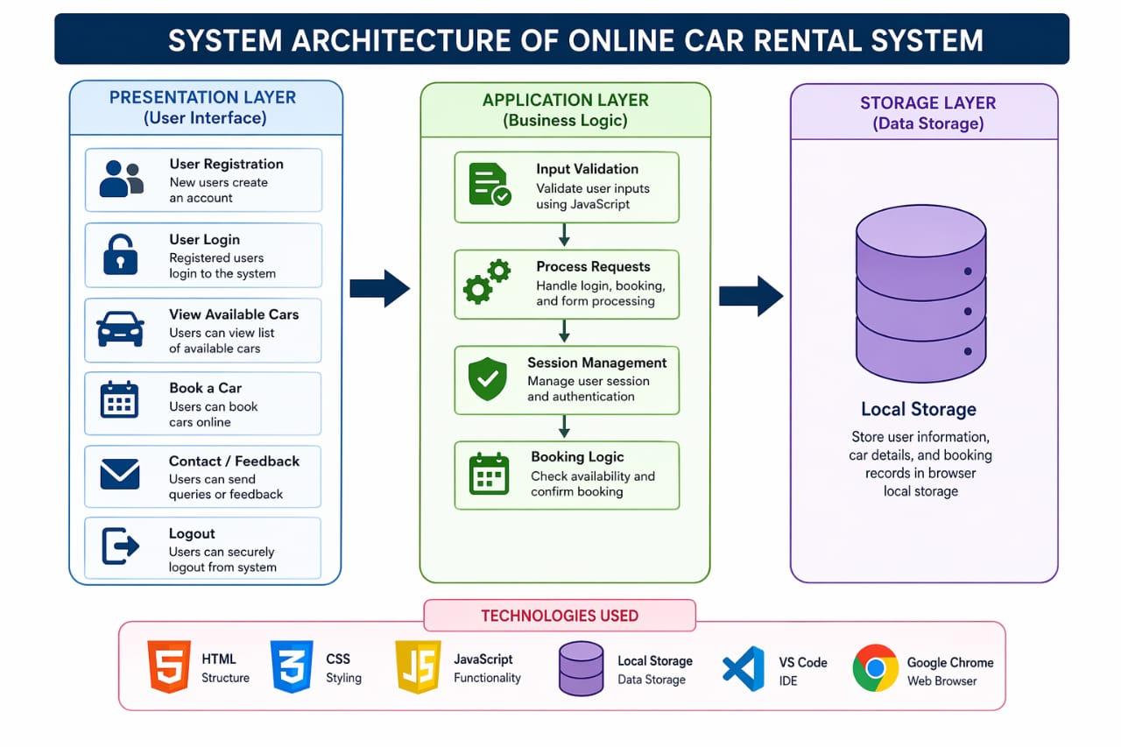

Use Case Diagram
Shows interaction between user and system
Activity Diagram
Shows workflow of booking process
Sequence Diagram
Shows step-by-step execution
4. IMPLEMENTATION
The system is developed using modern web technologies.
- HTML for structure
- CSS for styling
- JavaScript for logic
Development Process:
- Requirement analysis
- Design
- Coding
- Testing
4.1 SAMPLE CODE:
<!DOCTYPE html>
<html>
<head>
<title>Online Car Rental System</title>
<style>
body { font-family: Arial; margin: 0; }
nav { background: #1e3a5f; padding: 15px; text-align: center; }
nav a {
color: white;
margin: 15px;
text-decoration: none;
font-size: 18px;
cursor: pointer;
}
.section { display: none; padding: 30px; text-align: center; }
input, select, textarea {
padding: 10px;
margin: 10px;
width: 250px;
}
button {
padding: 10px 20px;
background: blue;
color: white;
border: none;
cursor: pointer;
}
</style>
</head>
<body>
<!-- Navbar -->
<nav>
<a onclick="showSection('home')">Home</a>
<a onclick="showSection('booking')">Book Car</a>
<a onclick="showSection('contact')">Contact</a>
</nav>
<!-- Home -->
<div id="home" class="section">
<h2>Welcome to Online Car Rental System</h2>
<p>Book your favorite car easily and quickly.</p>
</div>
<!-- Booking -->
<div id="booking" class="section">
<h2>Book Your Car</h2>
<select id="car">
<option value="">Select Car</option>
<option>Swift</option>
<option>Innova</option>
<option>Creta</option>
</select><br>
<input type="date" id="startDate"><br>
<input type="date" id="endDate"><br>

<button onclick="bookCar()">Confirm Booking</button>
</div>
<!-- Contact -->
<div id="contact" class="section">
<h2>Contact Us</h2>
<input type="text" id="name" placeholder="Your Name"><br>
<input type="email" id="email" placeholder="Your Email"><br>
<textarea id="message" placeholder="Your Message"></textarea><br>
<button onclick="sendMessage()">Send Message</button>
</div>
<script>
// Show section
function showSection(sectionId) {
let sections = document.querySelectorAll(".section");
sections.forEach(sec => sec.style.display = "none");
document.getElementById(sectionId).style.display = "block";
}
// Default page
showSection('home');
// Booking function
function bookCar() {
let car = document.getElementById("car").value;
let start = document.getElementById("startDate").value;
let end = document.getElementById("endDate").value;
if(car === "" || start === "" || end === "") {
alert("Please fill all details!");
return;
}
let booking = {
car: car,
startDate: start,
endDate: end
};
localStorage.setItem("booking", JSON.stringify(booking));
alert("Booking Confirmed!");
}
// Contact function
function sendMessage() {
let name = document.getElementById("name").value;
let email = document.getElementById("email").value;
let message = document.getElementById("message").value;
if(name === "" || email === "" || message === "") {
alert("Please fill all fields!");
return;
}
let contact = {
name: name,
email: email,
message: message
};
localStorage.setItem("contact", JSON.stringify(contact));
alert("Message Sent Successfully!");
}
</script>
</body>
</html>

4.2 TEST CASES
Test Case | Description | Expected Result
Registration | Valid details | Account created
Login | Correct credentials | Success
Login | Incorrect credentials | Error message
Booking | Valid dates | Booking success
Booking | Invalid input | Error

5. RESULTS
The Online Car Rental Management System was successfully developed and tested using HTML, CSS, and JavaScript. The system provides a smooth and efficient platform for users to perform car rental operations online. All the modules were implemented correctly and tested under different conditions to ensure proper functionality.
The user registration and login module works effectively by allowing new users to create accounts and existing users to log in securely. Validation techniques ensure that only correct and complete data is accepted, reducing errors and improving system reliability.
The car listing module displays available vehicles clearly with details such as car type, model, and rental price. Users are able to easily browse through different categories like Sedan, SUV, and Hatchback, which improves user experience and helps in quick decision-making.
The booking module performs efficiently by allowing users to select rental dates and confirm bookings without any complications. The system stores booking details using browser Local Storage, ensuring that data is retained during the session and can be accessed when required.
The contact and feedback modules also function properly, enabling users to communicate with the administrator and provide suggestions. This helps in improving the overall system performance and service quality.
Performance Evaluation
The system responds quickly to user inputs
Pages load without delays in modern browsers
Booking process is completed in minimal steps
Data is stored and retrieved efficiently
Accuracy
All user inputs are validated before processing
Booking details are stored correctly
No duplication or data inconsistency observed
User Satisfaction
Simple and user-friendly interface
Easy navigation between pages
Reduced time for booking compared to manual systems
Overall Outcome
The system achieved its primary objective of automating the car rental process. It reduces manual effort, minimizes errors, and improves efficiency. The results clearly demonstrate that the proposed system is reliable and effective for small-scale car rental operations.
Output Screens:
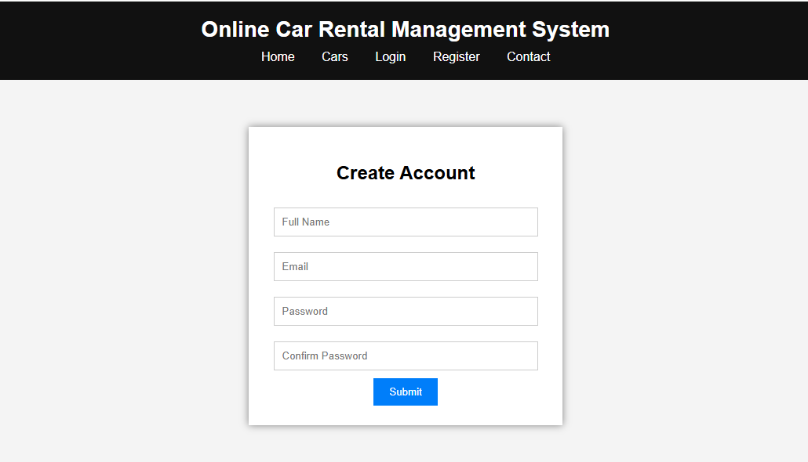
Figure 1: User Registration Page of Online Car Rental Management System
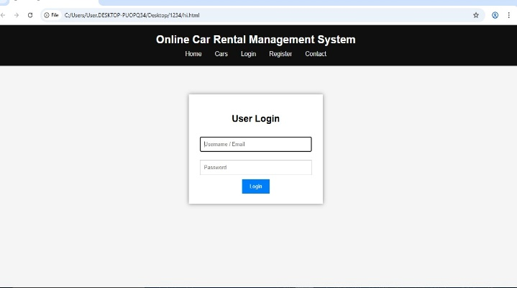
Figure 2: User Login Page of Online Car Rental Management System
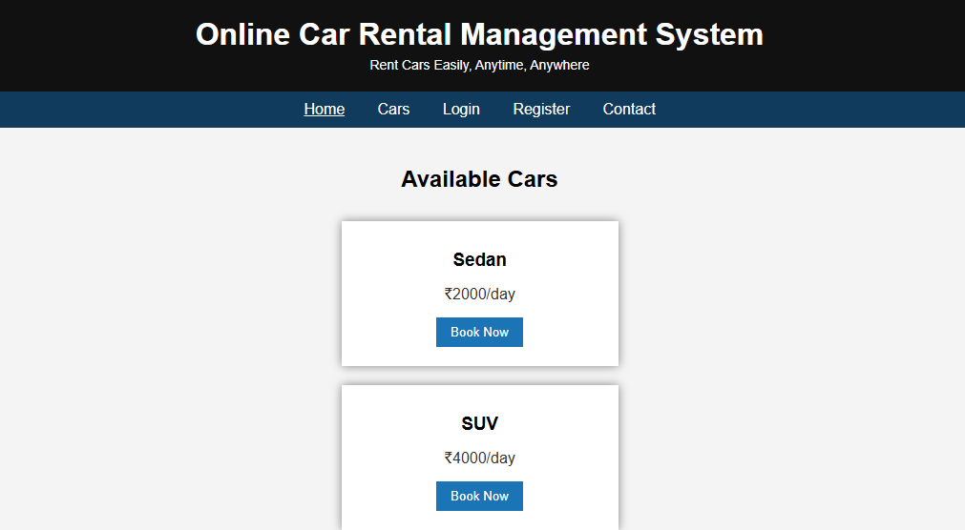
Figure 3: Available Cars Page of Online Car Rental Management System
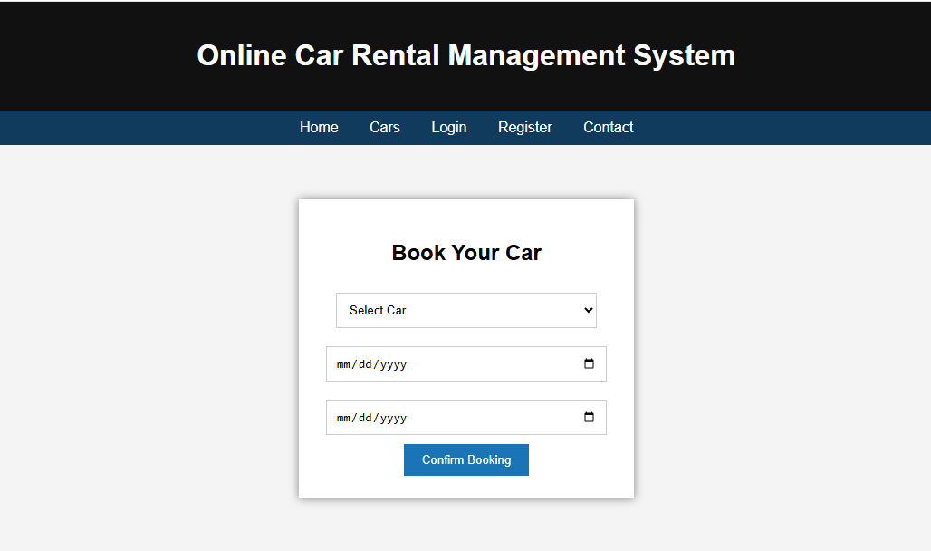
Figure 4: Car Booking Page of Online Car Rental Management System
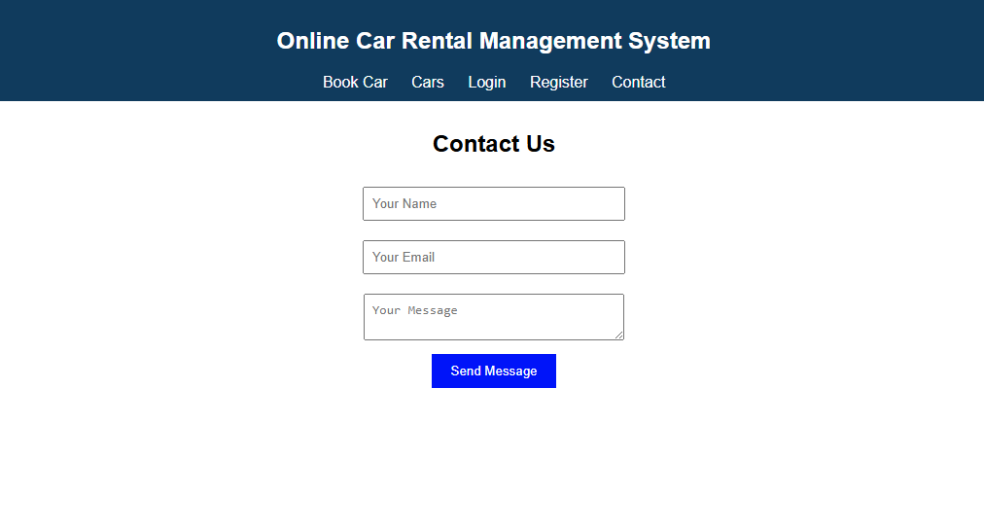
Figure 5: Contact Us Page of Online Car Rental Management System

Conclusion:
The Online Car Rental Management System successfully demonstrates how modern web technologies can be used to transform traditional business operations into an efficient digital platform. The system simplifies the process of vehicle booking by allowing users to search, select, and reserve cars online without the need for physical interaction. This significantly reduces time, effort, and operational complexity for both customers and administrators.
The implementation of the system using HTML, CSS, and JavaScript proves that even front-end technologies can be effectively utilized to build a functional and interactive application. The use of browser Local Storage enables temporary data management, making the system suitable for small-scale applications and prototype development.
One of the key achievements of this system is its user-friendly interface, which ensures ease of navigation and accessibility for users with basic technical knowledge. The modular design approach also makes the system flexible and easy to upgrade in the future. Each module, such as registration, login, car listing, booking, and feedback, works together to provide a smooth and integrated user experience.
Although the current system has certain limitations, such as lack of server-side database and advanced security features, it provides a strong foundation for future enhancements. With further improvements like database integration, payment gateway support, and mobile application development, the system can be scaled into a full-fledged commercial solution.
In conclusion, the Online Car Rental Management System not only meets its objectives but also highlights the importance of automation in improving service quality, reducing manual errors, and enhancing customer satisfaction. It serves as a practical example of how digital solutions can be applied to real-world problems to achieve better efficiency and performance.

References:
IEEE,
“DriveEasy: Car Rental Management System,” Applied Information Technology and Computer Science, vol. 6, no. 1, pp. 861–880, 2025.
→ This paper explains how automation improves efficiency in car rental services and highlights the importance of web-based solutions.
Dinesh Kumar, Deepak Bartwal, and G Kannan,
“Online Car Rental System,” IJRDO Journal of Computer Science Engineering, vol. 7, no. 5, pp. 11–16, 2021.
→ This study focuses on system design and implementation of online rental platforms using web technologies.
Mohd Nizam Osman et al.,
“Online Car Rental System using Web-Based and SMS Technology,” Journal of Computing Research and Innovation, vol. 2, no. 3, pp. 33–38, 2017.
→ This research highlights integration of communication technologies such as SMS with web-based systems.
D. Sari and M. Abu Jihad,
“Design of a Web-Based Car Rental Service Portal Information System,” Jurnal Mandiri IT, 2025.
→ This paper discusses system architecture and user interface design for rental platforms.
W3Schools,
“HTML, CSS, and JavaScript Tutorials.”
Available: https://www.w3schools.com⁠�
→ Used as a reference for front-end development concepts and implementation.
Mozilla Developer Network,
“JavaScript and Web APIs Documentation.”
Available: https://developer.mozilla.org⁠�
→ Provides detailed explanation of JavaScript functions, validation, and browser storage.
Google,
“Google Chrome Browser Documentation and Developer Tools.”
→ Used for testing and debugging the application.
Microsoft,
“Visual Studio Code Documentation.”
→ Used as the development environment for coding and project implementation.

